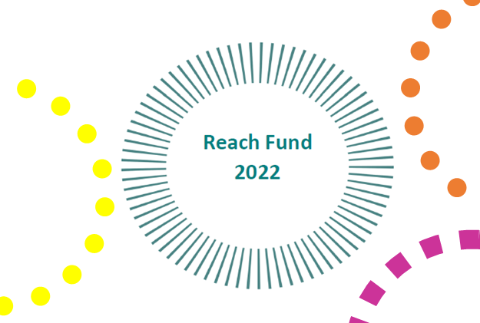

Internal Application Form for Funding

- Projects to be completed by 2022 year-end.
- Funding applications should only be made for projects that cannot be funded under normal FET programme funding arrangements
- The REACH Fund replaces the Mitigating Against Educational Disadvantage (MAED) Fund that was operable in 2020 and 2022
- Applications must be received by 29th July 2022

Section 1 – project costs/funding
Cost of project | €
Grant request (the grant amount sought in this application) |  |  | €
If the total cost of the project is greater than the amount of the grant sought, please outline where and how the balance of funding will be secured:
Project costs for each of the following, where applicable (grant amount sought for each)
- Learner assistance fund, inclusive of education outreach/mentoring projects/transport costs for learners/urgent educational response |  | €
- Innovative green projects. |  | €
- Projects focused on increasing participation in learning with target cohorts. |  | €
- Events/awareness campaigns that contribute to equality policy and legislation. |  | €
- Projects in line with the ALL strategy, specific actions that:  - directly address those experiencing unmet literacy needs  - target funding on access to technology and devices  - expand community access to Wi-Fi and broadband resources |  | €
- Projects to support pre-development supports for marginalised/disadvantaged groups |  | €
- Support for refugee groups to support education and training delivery and promote/ support cultural and social inclusion, including research and/or needs analysis. |  | €

Section 2 – Project details
Project proposed
Please provide a synopsis of the project proposed under the specific funding criteria that the grant is sought for:
Funding Criteria | Target Group(s) | Funding Purpose
Learner Assistance Fund
Innovative Green Projects
Increasing target cohort Participation
Equality Policy and Legislation Awareness
ALL Strategy Actions
Community Group Predevelopment
Refugee Supports
Please include any additional information regarding the target group(s) you wish to add to support this application:
Please provide information demonstrating how this funding intends to mitigate educational disadvantage for the cohort identified:
Please outline how the funding can complement and/or enhance the current provision of similar education in the area.
Please clarify how this funding will support your learners to achieve positive outcomes as a result of this support:
How will the benefits of this funding be measured?
Please provide information on how this project represents value for money and indicate what steps the project has taken to ensure avoiding duplication with existing services in the area:

Section 4 – Submission Details
That I have the appropriate authority to make this submission for funding. This application for funding form is fully completed and the information provided is a full and accurate account of how the funding (if allocated) will be used in 2022.
Signature |  |  | Print name
Position in organisation |  |  | Date

A condition of funding is that recipient organisations will submit, in the timeframe requested, a detailed report to Cork ETB on the benefits accruing to learners from the funded project.
Applications to be submitted to Cork ETB
Closing date for receipt of applications: 29th July 2022

